A57-Am,C-Colombia-Tairona-Gold Figurine-Bat-Human Male-Finial-1000-1500 CE

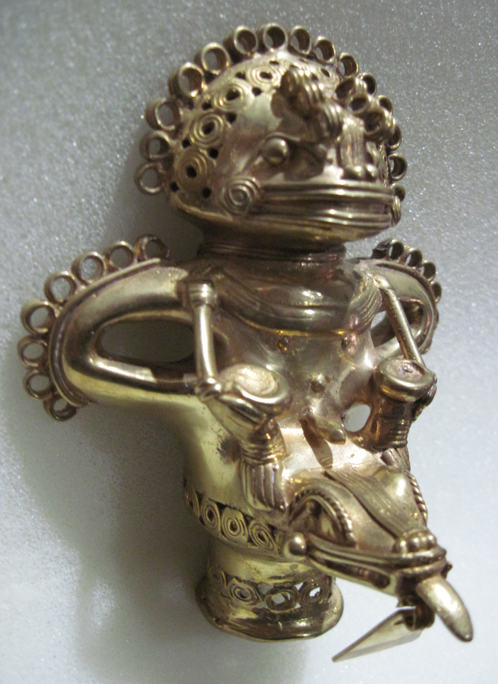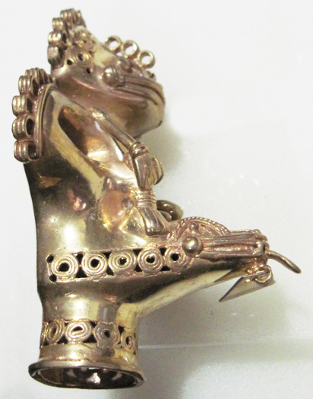 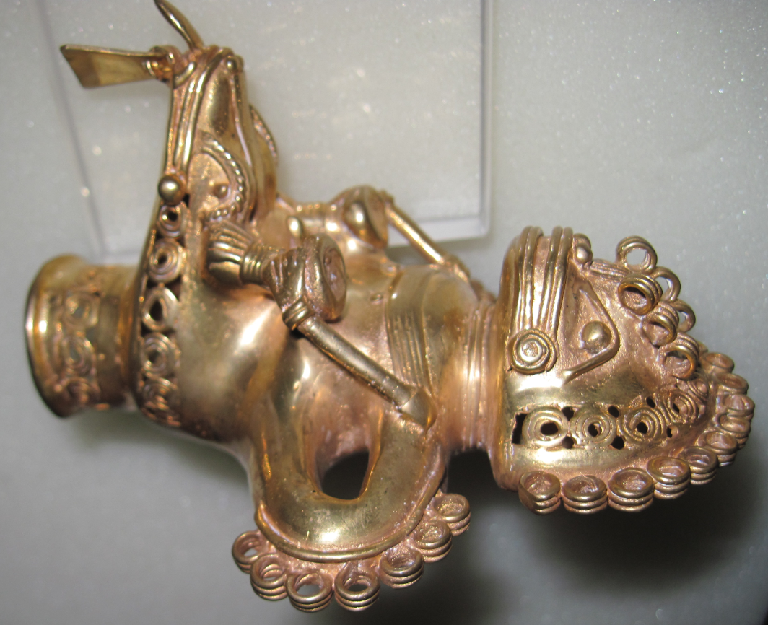 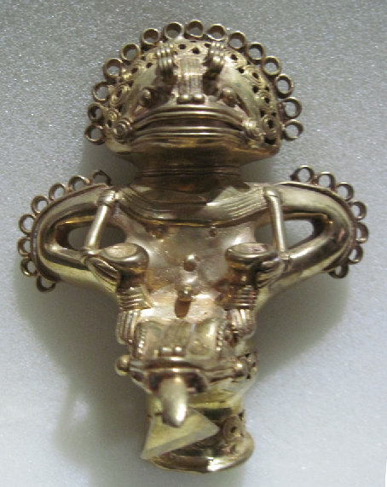 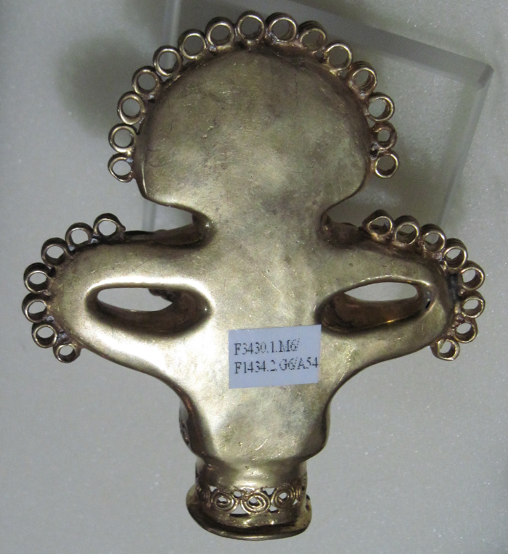

Figs. 1-5. Colombia-Tairona-Gold Figurine-Bat-Human Male -Finial-1000-1500 CE

**Case no.: 7**

**Accession Number: A57**

**Formal Label:** Colombia-Tairona-Gold Figurine-Bat-Human Male-Finial-1000-1500 CE

**Display Description:** Anthropomorphic male figure is wearing a mask with a prominent snout, strong jaws, bared teeth, and a nose-leaf characteristic of the *Phyllostomidae* Bat Family.Above are 15 circular elements closely spaced in in a semi-circle around 10 circular elements in the headdress. The wing appendages also have 7 circular elements closely spaced at their apexes. The figure is ithyphallic and is holding the two horns of a crocodile-like figure on which he appears to be riding. Circular elements also adorn the left (5) and right (6) sides of the crocodile’s head. The base of the finial has 2 circular elements. This design is similar to a figure in the Gold Museum in Bogotà (O26176).

In order to fully expose the issues that a *Máma* (priest) might be confronted with in the local community, the Tairona and their descendants were flexible in combining aspects of different images of animals, reptiles and birds syncretistically in figurines to highlight how these features of animal personalities were also found in their human counterparts. For instance, the bat, which inhabits caves and engages in procreative and supposedly homosexual activity, was used to address sexual attitudes of their society: they accepted homosexuality and procreation but put total restrictions on incest. Hence the figure is ithyphallic but has restrictions placed on his sexuality. This is elucidated in their myth of the bat Nurlitaba, the son of Enduksama.

**LC Classification:** F1434.2

**Date or Time Horizon:** 1000-1500 AD/CE

**Geographical Area:** Sierra Nevada de Santa Marta**, Colombia. Indigenous names are:** Kankuamo (*Umunukunu);* Kogi (*Gonawindua).*

**GPS Coordinates:** **10o57’N, 73 o 48’W**



Fig. 4. Map of Spanish Provinces in 1600. After <https://html2-f.scribdassets.com/5nmwqq7itc4aqx2e/images/6-a5a093175f.jpg>. Yellow place-holders mark the centers of the four Tairona cultures (in bold) as of 2017.

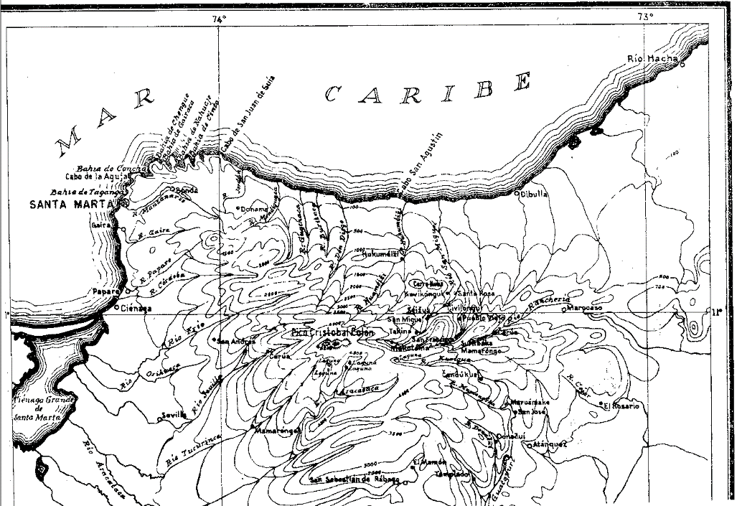

Fig. 5. Topographic map of the Sierra Nevada of NE Colombia. From Reichel-Dolmatoff 1950.

**Cultural Affiliation:** Tairona, Chibcha Language

**Medium:** Lost-wax cast of tumbaga, an alloy of gold and copper. Its surface was subsequently enriched by the depletion method, also known as *mise-en-couleur*.

**Dimensions:**

**Weight:**

**Condition: original**

**Provenance:** Tairona villages

**Discussion:** The bat in Tairona spirituality is the son of Mulkuexe, the sun, who allows Woman to begin her reproductive process and therefore the anthropomorphic-bat has an important place in Tairona mythology and mores (see Legast 1989).

“In the beginning there was no Sun. Rotten sticks were all that shone in the forest. Everything else was darkness. At that time Mother Gualchováng had two sons, Mulkuexe and Sintana. They lived in Mulkuagakve [a place near Hukumeiji in the Sierra de Santa Marta]. Mulkuexe’s wife was Namshaya [the jaguar woman] and their son was Enduksama [the deity of the planet Venus]. … Mulkuexe was a Máma [or, priest] and was always fighting with Sintana. … Mulkuexe was a bad man. He had a lot of gold and was like a Sun, but he liked to burn the Earth with his light. … Sometimes he made everything go dark [as in a Lunar eclipse of the Sun] and nobody could find their way along the road. Sintana used to give him advice but Mulkuexe would not listen.

And so Sintana thought, “What will I do?” He went to Mulkuexe and said, “They tell me that many men sleep with their daughters.” Mulkuexe got angry and said, “That is very bad.” So Sintana took hold of Enduksama, Mulkuexe’s son, and also his wife, Namshaya, and carried them off to his house. He changed Enduksama into a woman and gave him beautiful hair. But he dressed Namshaya in a simple carate [cotton rag] shirt. Then he said to Namshaya, “Go back to Mulkuexe so that he will do it [make love to] Enduksama. “ So Namshaya and Enduksama went back to Mulkuexe’s place, but he did not recognize them. And Mulkuexe fell in love with Enduksama and said to Namshaya, “I like your daughter very much. Give her to me.” Then Namshaya said, “Very well.” Mulkuexe took a piece of gold, a round piece that he had on his chest, and gave it to Namshaya. … The Enduksama grew fat and after seven months gave birth to a son called Nurlitaba [the bat]. He was like a bird. Enduksama took hold of him and threw him in the bushes. But Namshaya found him and began to rear him. And so, when the child could speak he met Mulkuexe and addressed him Father-Grandfather. Then Mulkuexe realized what had happened, and he felt a great shame. He sent Enduksama faraway never to see him again. Ever since then Enduksama [Venus] comes out earlier than the Sun. … There already existed a Sun on Earth but it did not work very well. Sintana now took Mulkuexe and sent him up to heaven as the Sun. And Namshaya was sent as the Moon” (Reichel-Dolmatoff 1950-1951, 2:26-27).

Nurlitaba, the bat, the first in creation, therefore finds a place in the gold figurines as a revered one and one that has a special meaning for women.

In 1965, Colombian archaeologists discovered a previously unrecorded mountain trail of 1,200 stone steps in the rain forest ("Infierno verde" or "Green Hell") on the slopes of Sierra Nevada de Santa Marta, which led to an abandoned city (“Ciudad Perdida”; 11°02'22.9"N 73°55'33.8"W) where they excavated gold figurines and ceramic urns. Tairona descendants—the Arhuaco, the Kankuamo, the Kogi and the Malayo—re-called the site “Teyuna” with its series of 169 terraces and several small circular plazas, which, in the 5th century AD/CE, had been the growing center of a network of ancient villages. This gold figurine was possibly found in this area in the early 20th century.

Tairona spirituality in its Kogi version is based on *aluna*, cosmic harmony. The central figure of Kogi religion is the Universal Mother or Gaulcováng (from gau – “to create”), is the creator at the beginning of time of the “Cosmic Egg” that encompasses the universe. The Universal Mother, has many manifestations, such as **Hába Guxsénse**, “Mother of the Eternal Fire,” and Málkwa-yang, “Mother of the Knowledge of Weaving.” (Reichel-Dolmatoff 1975; 1985; 1987; 1990). The Kogi Cosmic Egg is composed of nine worlds that correspond to the nine months of human gestation (Tairona 2015).

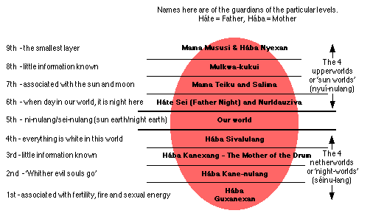

Fig. 6. Structure of the Kogi Cosmic Egg. Based on Reichel-Dolmatoff 1978, from Tairona 2015.

This egg-shaped universe has nine superimposed levels, and humankind occupies the middle one of these. The four upper levels (nyui-nulang, sun worlds) each have their own suns. The sun of the third level is Teiku, who lives there with his “family” of celestial beings, planets, and constellations. The principal divinities are the Universal Mother’s sons—Seokukui, Seizankwa, Kuncavitabueya, Aldauhuiku, and Mulkuexe who balance the Cosmic Egg on their lances that are carried on their shoulders. These two lances are symbolized architecturally in the Kogi domiciles and can be seen protruding from the roofs.

Tairona spirituality in its Arhuaco version is based on Kunsamü, a sacred, pre-existent, universal law that aims to preserve equilibrium and harmony among all things. The father-creator Kakü Serankua, in the beginning, molded Chundúa in Iku, the language of the Arhuacos, the highest snow-covered peak (named by the Spanish “Pico de Cristobal Colon” to de-sacralize it) of the central massif (named by the Spanish “Sierra Nevada de Santa Marta” to re-sacralize it) Umunukunu in Iku. Umunukunu is thought to be the “Heart of the World” and the “Origin of Life”. Kakü Serankua also created the first gods, and the first men -- the Elder Brothers – the Taironas -- and bestowed upon them the duty of protecting the earth. The Umunukunu are akin to their bodies, with the highest peak corresponding to their head, the lagoons and lakes below to their heart, the rivers and streams to their veins, the layers of soil to their muscles, and the scrublands to their hair.

Combining the spirituality of the Kogi and the Arhuaco we can see that a duality is implied by their common ancestor, the Tairona, in which there was probably both a Mother Creator and a Father Creator. Duality may be seen in many of the gold artifacts of the Tairona suggesting a complex interweaving of complimentary ideas and visual themes